Supplementary material

Supplementary Table 1. List of forward and reverse primer sequences used in qPCR.

|  |  |  |  |  |  |
| --- | --- | --- | --- | --- | --- |
| SI. No | Gene | | | | Primer Sequence |
| Name | Official Name and Symbol (NCBI) | Expected Amplicon size | Primer | 5′→3′ |
| 1 | Beta actin | Actin beta(*ACTB*) | 191 bp | Forward | ACAGAGCCTCGCCTTTGC |
| Reverse | CCACCATCACGCCCTGG |
| 2 | Androgen receptor | Androgen Receptor(*AR*) | 164 bp | Forward | GACATGCGTTTGGAGACTGC |
| Reverse | TTCCCTTCAGCGGCTCTTTT |
| 3 | Estrogen receptor alpha (ERα) | Estrogen receptor1 (*ESR1*) | 174 bp | Forward | CTTGGACAGGAACCAGGGAAAA |
| Reverse | TTCAGGGTGCTGGACAGAAAT |
| 4 | Estrogen receptor beta (ERβ) | Estrogen receptor 2(*ESR2*) | 217 bp | Forward | GCATGCGAGATGGGGAGAAA |
| Reverse | GGGCCTTTAAGCTGGTTTGC |

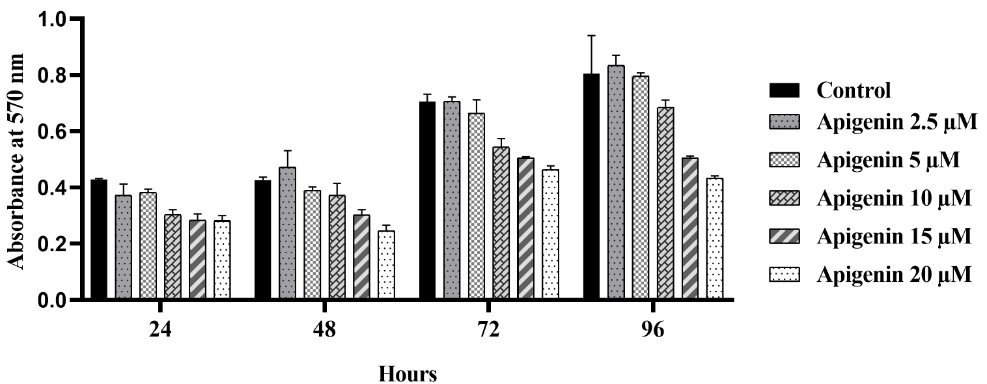

Supplementary Fig. 1. Growth of prostate epithelial cells under the treatment of different concentrations of apigenin.

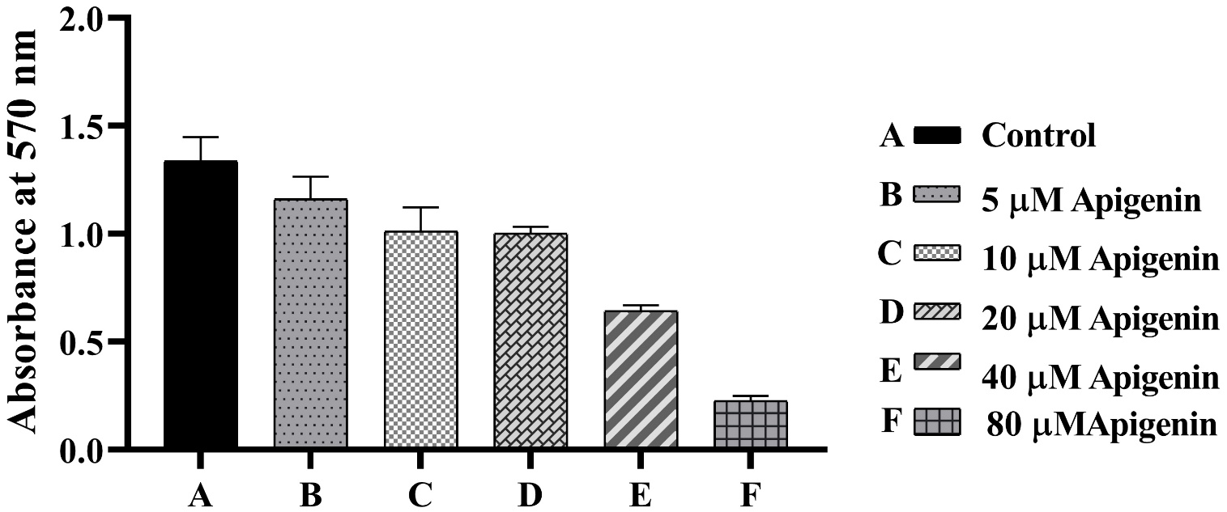

Supplementary Fig. 2. Growth of prostate stromal cells under the treatment of different concentrations of apigenin.